Capturing and Cracking Passwords Using Tcpdump, Arpsoofing and John the Ripper
Course Number: CMPS380
Instructor: Dr. Khaled Khan
Section No: L02
Group ID: G43
Submission date: 16th November 2025
Word Count:1522

Effort distribution:
Abdelrahman Abdelvahed– 202207121 – Effort (25%)
Amer Alzawawi– 202205054 – Effort (25%)

Maher Alwajih– 202210812 – Effort (25%)
Islam Abdulhamid– 202110979 – Effort (25%)

Introduction:
This project simulates a focused, web-oriented penetration test against a lab target to demonstrate how attackers move from discovery to compromise. Through an organized sequence of reconnaissance, traffic analysis, credential harvesting, and offline cracking, we show how weak operational choices (plaintext protocols, weak passwords) create an attack chain that an adversary can exploit. The project is performed in an isolated lab environment and uses commonly available tools to recreate realistic attack steps safely.

Project Overview:
The project walks through the full kill-chain of a credential-theft scenario: identify hosts and services with Nmap; perform a controlled Man-in-the-Middle (ARP spoof) to capture HTTP traffic with tcpdump, extract credentials from captured HTTP POSTs with Tshark, use those credentials to access a protected resource on the web server that exposes a file of password hashes, and finally perform offline password recovery with John the Ripper (or Hashcat). Each stage is documented with commands, capture evidence.

Objectives:
- Demonstrate practical reconnaissance using Nmap to discover live hosts and exposed services.
- Capture and analyze network traffic to reveal how insecure protocols leak credentials.
- Show how an attacker can pivot from captured credentials to fetch sensitive artifacts.
- Perform offline password cracking on harvested hashes to quantify the risk of weak passwords.

Key Features:
- Uses Nmap for systematic host discovery and service enumeration, illustrating how attackers identify potential targets and attack surfaces.
- Demonstrates passive and active traffic interception (tcpdump/Tshark and ARP-based MITM) to show how unencrypted HTTP can expose credentials in transit.
- Shows credential-based escalation: captured credentials are used to authenticate and retrieve a protected file of password hashes, modelling an attacker pivot.
- Employs offline password-recovery tools (John the Ripper / Hashcat) to quantify the vulnerability of weak or reused passwords and to demonstrate how quickly common passwords can be recovered.
- Highlights real-world consequences (unauthorized access, data exfiltration, and facilitation of further attacks) and connects technical findings to practical remediation: enforce TLS, use strong salted hashing (bcrypt).

Key Applications
- Awareness & training: Teach students, staff, and end-users about the practical risks of weak, reused, or unprotected credentials by demonstrating how they can be captured and exploited.
- Security assessment: Enable organizations and security teams to safely test web applications and internal networks in a lab environment to identify misconfigurations, exposed services, and weak password policies.
- Defense improvement: Inform development of detection and mitigation controls—such as anomaly detection for brute-force attempts, enforcement of strong password/hash policies, TLS adoption, and multi-factor authentication—by showing how common attack techniques operate in practice.

Tools Used:
- Kali Linux:
A purpose-built Linux distribution for penetration testing and digital forensics. Kali packages a wide collection of security utilities and simplifies running common offensive and defensive workflows in one environment. In this project Kali functions as the attacker platform — hosting Nmap, tcpdump/tshark, John the Ripper, Hydra, and Hashcat — and provides a convenient, reproducible lab environment.
- Nmap:
An open-source network scanner used for host discovery and service enumeration. Nmap identifies live hosts, open ports, running services and versions, and helps prioritize attack paths during the reconnaissance phase. Scan results are saved as evidence and inform the scope of subsequent capture and exploitation steps.
- ARP spoofing (arpspoof):
These utilities perform controlled ARP poisoning or proxying to position the attacker between a client and a server. In the lab they allow the attacker VM to observe unencrypted traffic between two hosts. The project uses these tools only in an isolated environment to demonstrate how traffic interception enables credential harvesting.
- tcpdump / tshark :
Packet capture and analysis tools used to collect and inspect network traffic. tcpdump records packet streams to .pcap files and tshark is used to extract HTTP POST bodies, decode captured data, and produce annotated evidence. These tools make it straightforward to demonstrate plaintext credential leakage and to export artifacts for later analysis.
- Node.js (simple web application):
A lightweight web server implemented in Node.js (Express) provides the vulnerable target: an HTTP login form and a protected download route that contains hashed password data. Node.js is easy to configure and modify for the lab (generate test users and serve files) and lets us reproduce the exact conditions that lead to credential exposure.
- John the Ripper / Hashcat:
Offline password-recovery tools used to demonstrate the risk of weak passwords. After the attacker downloads hashed password data, John performs dictionary and rule-based attacks to recover plaintext credentials from weak or common passwords. These tools quantify how quickly poor passwords can be broken.

Implementation Details:
- Environment setup: Create three VMs and place them on the same isolated virtual network: an attacker (Kali), a client (victim) and a server (web app). The web application was implemented in Node.js/Express and served an HTTP login form on port 8080. A small local data store (plain files) held demo user records and two downloadable hash artifacts (hashes_raw_md5.txt) kept under a protected route accessible only to an authenticated user (Alice).
- Reconnaissance (Nmap): From Kali we enumerated the lab network to discover live hosts and services with Nmap (host discovery and targeted port/service scans). Results used to identify the target web server address and open ports.
- Positioning the attacker (MITM): To observe client to server traffic, the attacker performed a controlled man in the middle using ARP spoofing (arpspoof). IP forwarding was enabled on the attacker VM so traffic would be relayed and normal client server communication would continue while being captured.
- Traffic capture (tcpdump and tshark): While the MITM was active, the attacker captured network packets with tcpdump and inspected them with tshark. The capture focused on HTTP traffic to port 8080. HTTP POST bodies containing form fields were extracted from the pcap file and decoded (hex to ASCII) to reveal the plaintext credentials submitted by the victim.
- Credential reuse and data retrieval: Using the harvested credentials (Alice’s username and password), the attacker logged in to the web application and downloaded the protected hash file stored on the server.
- Offline cracking (John / Hashcat): The downloaded hash file was prepared for offline cracking. John the Ripper (and alternatively Hashcat) was used to perform dictionary and rule-based attacks against the hash set to recover weak plaintext passwords. Command invocations cracked output and timings were recorded.

Learning Outcomes:
This project provided practical, hands-on experience with the main stages of a web-oriented penetration test: reconnaissance, traffic analysis, credential exploitation, and offline password recovery. Working through the lab, we learned to:
- Use Nmap to perform systematic host discovery and service enumeration, and to interpret scan results to prioritize attack vectors.
- Capture and analyse network traffic with tcpdump / tshark, extracting application-layer data (for example HTTP POST bodies) and understanding how unencrypted protocols leak sensitive information.
- Execute a controlled man-in-the-middle (ARP spoofing) in an isolated lab to demonstrate the risks of plaintext authentication and to collect forensic evidence safely.
- Implement a simple web target (Node.js + protected route) and practice authenticated access and session handling, including how stolen credentials can be reused to access sensitive resources.
- Prepare harvested password material for offline analysis and apply John the Ripper and hashcat to evaluate the practical risk posed by weak passwords.
- Produce reproducible artifacts (pcap files, Nmap outputs, hash files, and cracking logs) and write concise remediation guidance that maps technical findings to actionable controls.

Overall Impact:
Penetration testing help defenders find and fix security problems, but the same techniques can be misused by attackers. This project demonstrates that a short chain of actions scanning, intercepting unencrypted traffic, reusing captured credentials, and cracking weak hashes can lead to serious compromise. Running these exercises in an isolated, authorized lab teaches practitioners how vulnerabilities appear in real systems and which controls (TLS, strong salted hashing, authentication, logging) effectively reduce risk. Because these tools are widely available, organisations should assume attackers will try similar methods and therefore incorporate regular testing, monitoring, and remediation into their security practices. Above all, exercises like this translate abstract security policy into practical improvements, while underscoring the ethical requirement to perform such work only with authorization.

Project limitations and Study Focus:
The tools used (Nmap, ARP-spoofers, tcpdump/Tshark, John) are useful for demonstrating attack techniques, but each has practical limits. offline crackers depend on the hash type and on whether the correct wordlists or compute resources are available and ARP-spoofing requires being on-path or actively manipulating the network. All experiments were performed on isolated virtual machines. This is necessary for ethics and safety, but it reduces realism. Production networks normally have additional protections (IDS/IPS, firewalls, WAFs, rate-limiting, centralized logging) that can prevent or detect the attack chain we demonstrated. Therefore, a successful attack in the lab does not guarantee success against a well hardened system. Password cracking and broad scanning require substantial CPU/GPU time and storage. For practical reasons the project used limited wordlists, a small set of accounts, and conservative cracking parameters. These choices make the exercise feasible in a student lab but limit how fully the results reflect large-scale, resource-intensive attacks. The study deliberately focuses on credential capture and password-based attacks over the network (plaintext HTTP, MITM, offline cracking). It does not examine other important threat types such as phishing, social engineering, or complex application logic flaws.

Appendix A:
Amer Alzawawi:
My role in this project focused on testing different approaches and determining which techniques were both realistic and manageable for our team. Throughout the development of the final system, I worked on generating the weak-hash files and simplifying the Node.js web application so that captured credentials could be demonstrated effectively in a controlled environment. I reviewed multiple designs for login handling, session management, and file protection to ensure the final setup remained simple enough for demonstration while still reflecting real attack chains. This project significantly improved my understanding of how credential theft can occur through network-level attacks and how weak hashing practices make systems vulnerable to offline cracking.

Islam Abdulhamid:
My contribution involved preparing the lab environment and performing the initial reconnaissance. I conducted network discovery and service enumeration using Nmap, refining the scan parameters to match a realistic attacker workflow. I also configured ARP spoofing within the virtual network and tested whether credentials sent via HTTP could be intercepted. In addition, I prepared some documentation. Through this work, I gained a clearer understanding of how attackers map networks, identify weak points, and rely on misconfigurations such as plaintext traffic to extract sensitive data.

Abdelrahman Abdelvahed:
My responsibility centred on packet capture and credential extraction. Using tcpdump and Tshark, I analysed HTTP login traffic, identified unencrypted POST requests, and extracted usable username–password pairs. After obtaining these credentials, I performed offline password cracking using tools such as John the Ripper and Hashcat to demonstrate how weak or predictable hashes can be quickly broken. This gave me practical insight into the importance of encryption, proper hashing algorithms, and secure communication channels. The hands-on analysis also highlighted how easily attackers can exploit insecure network traffic in real-world scenarios.
Maher Alwajih:
In this project, I focused on coordinating the group’s workflow and validating the technical steps across the attack. I helped refine the simplified Node.js server so the credential capture demonstration remained realistic yet safe for a controlled environment. I also verified the behaviour of the ARP spoofing setup and ensured the project documentation clearly explained each phase of the attack, from discovery to credential compromise to offline cracking. Working on this project reinforced the idea that attackers rarely depend on a single tool instead, they combine multiple techniques to exploit weaknesses at different stages of a system’s lifecycle.

Appendix B:

1-Prepare the web server
  - Install Node.js / npm
sudo apt update
sudo apt install -y nodejs npm
  - Install Node dependencies:
npm init -y

  - Create_user.js: 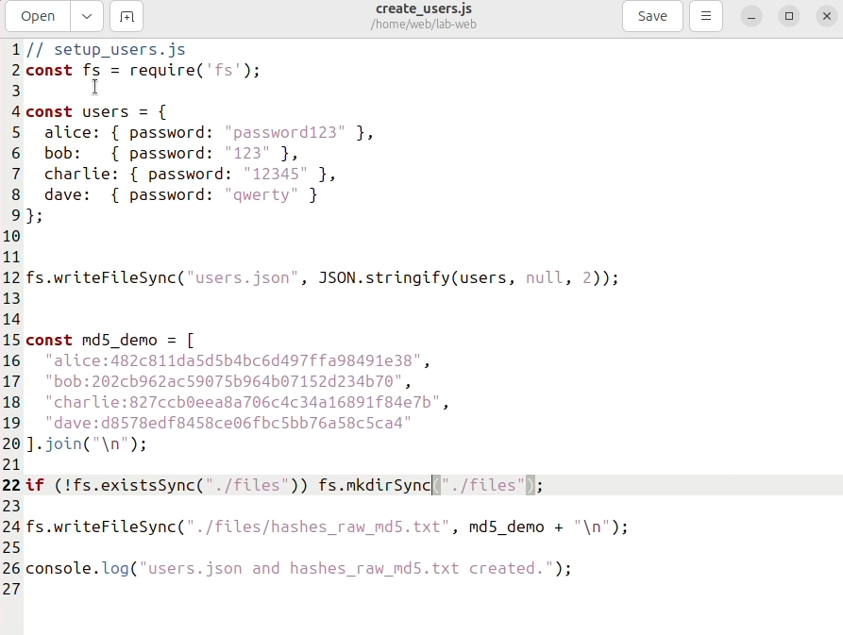
This Node.js script creates two files: a users.json file with plaintext passwords for four users, and a hashes_raw_md5.txt file containing MD5 hashes of those same passwords and there username to be downloaded later
  - Server.js:
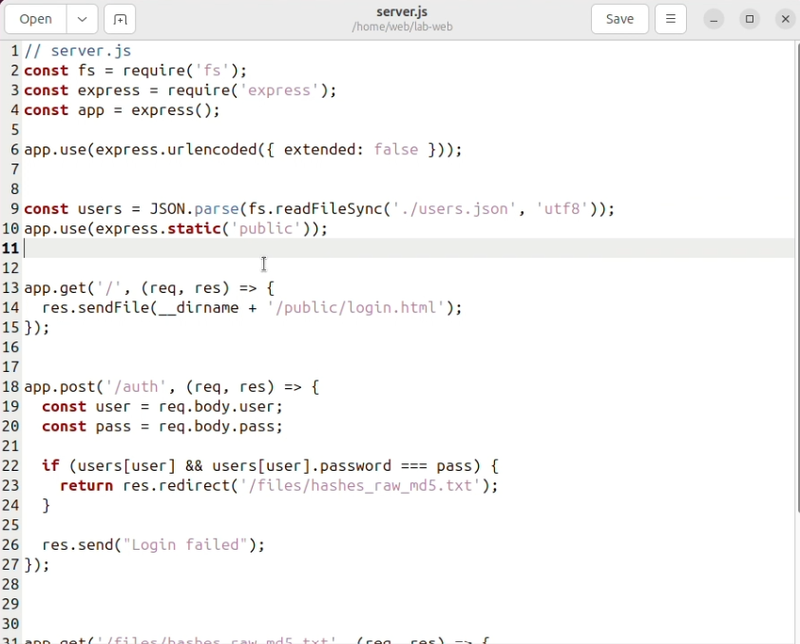

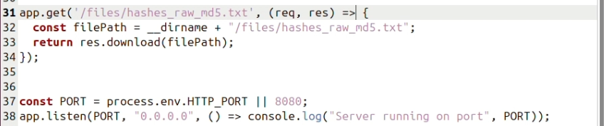

This JavaScript code provides a login system that authenticates users against plaintext passwords from a JSON file, and if successful, redirects them to download an MD5 hash file

2- user manual:

  - In Kali Linux, open the terminal and perform a network host discovery scan using the command nmap -sn 192.168.10.0/24 The -sn option performs a ping sweep to identify live hosts without port scanning. the scan results which will display all active hosts with their IP addresses and MAC addresses, revealing two VirtualBox virtual machines at 192.168.10.18 and 192.168.10.19 in this image: 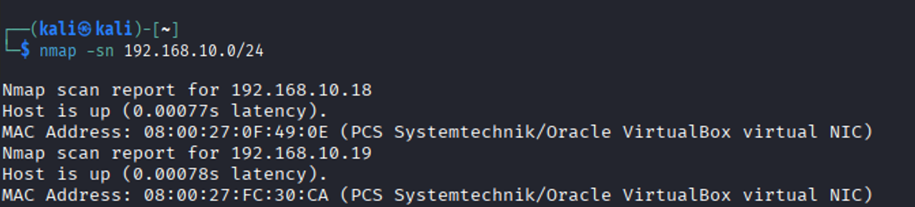
  - Now we will use nmap 192.168.10.18 this default Nmap scan detects the most common 1000 TCP ports on the target host at 192.168.10.18 and it shows that Port 80/tcp: Open - HTTP web service and Port 8080/tcp: Open - HTTP-proxy service
as shown in the image which mean this is a web server.
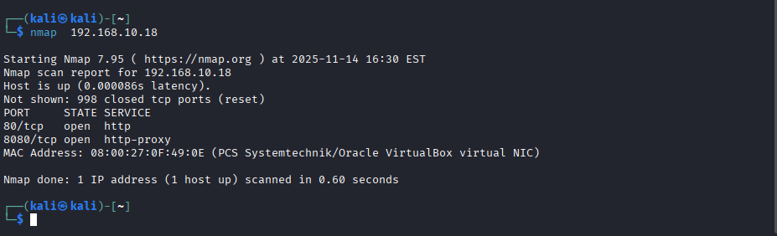

  - In this step we will make a man in the middle attack using arpspoof but first we should enable Ip forwarding by this command sudo sysctl -w net.ipv4.ip_forward=1 this will make kali act like a router between the web server and the client. After that Open two terminal windows in Kali Linux for bidirectional ARP spoofing. 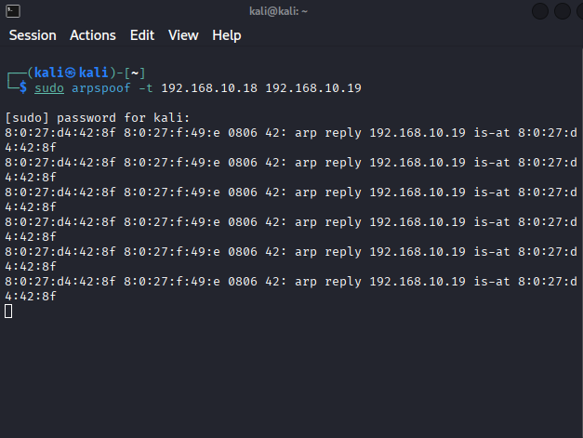
The image above makes 192.168.10.18 believe that the attacker's MAC address belongs to 192.168.10.19

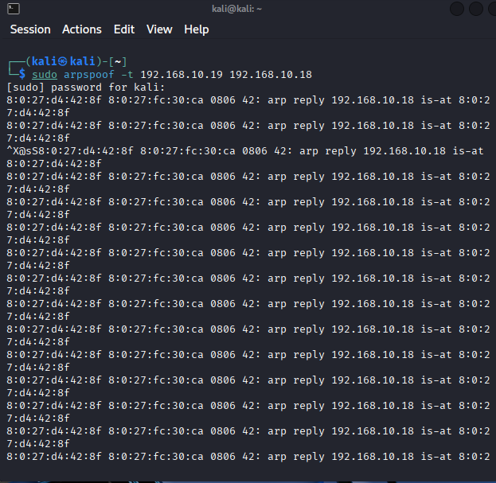

The image above makes 192.168.10.19 believe that the attacker's MAC address belongs to 192.168.10.18.

  - We will use tcpdump to capture and analyze network traffic between web server and client. In Kali Linux, open the terminal and start packet capture using the command sudo tcpdump -i any host 192.168.10.18 and tcp port 8080 -w web_capture.pcap -s 0 -nn.
-i any = Capture from all network interfaces and host 192.168.10.18 = Filter traffic to/from the target host and tcp port 8080 = Focus on TCP traffic on port 8080 (HTTP-proxy service) and -w web_capture.pcap = Save captured packets to a file for later analysis
  - Now we should log in from the client machine:
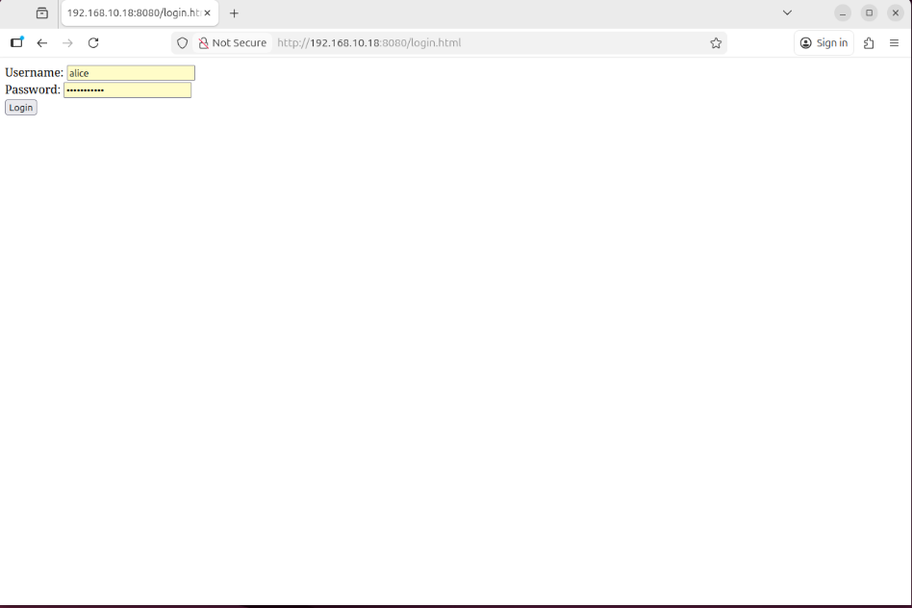
Stop the tcpdump command in the attacker machine and see the result:
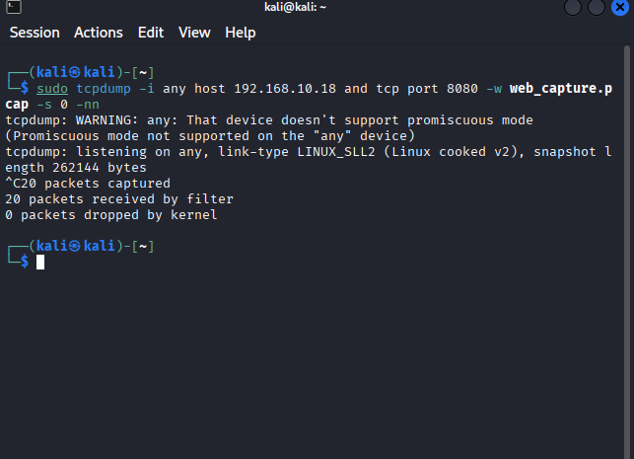
As we can see in the image above it have captured 20 packets successfully and saved in web_capture.pcap file.
  - Now, We will use tshark to extract and analyze HTTP POST requests from our captured network traffic file, specifically looking for authentication data that was transmitted using this command tshark -r web_capture.pcap -Y 'http.request.method="POST"' -T fields -e ip.src -e http.host -e http.request.uri -e http.file_data. We use 'http.request.method="POST"' to filter the post requests and -e to specify the fields in the file.
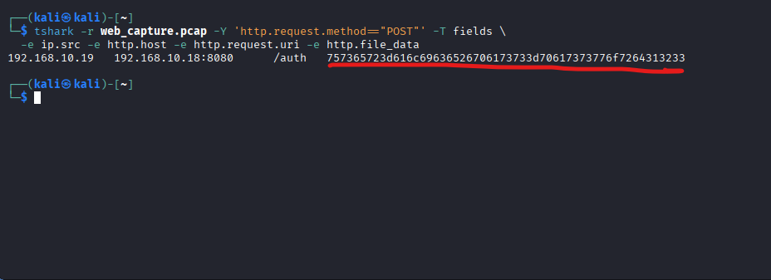
As we can see in the image above, we manage to get the password but in hex format. Now we use any hex converter online to see the password as string.
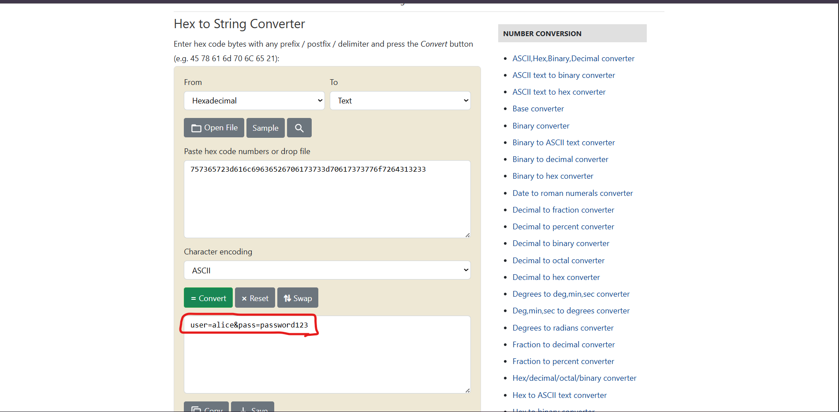
Now we manage to get the password and login to download the file that contain the user and hashed password as the image below.
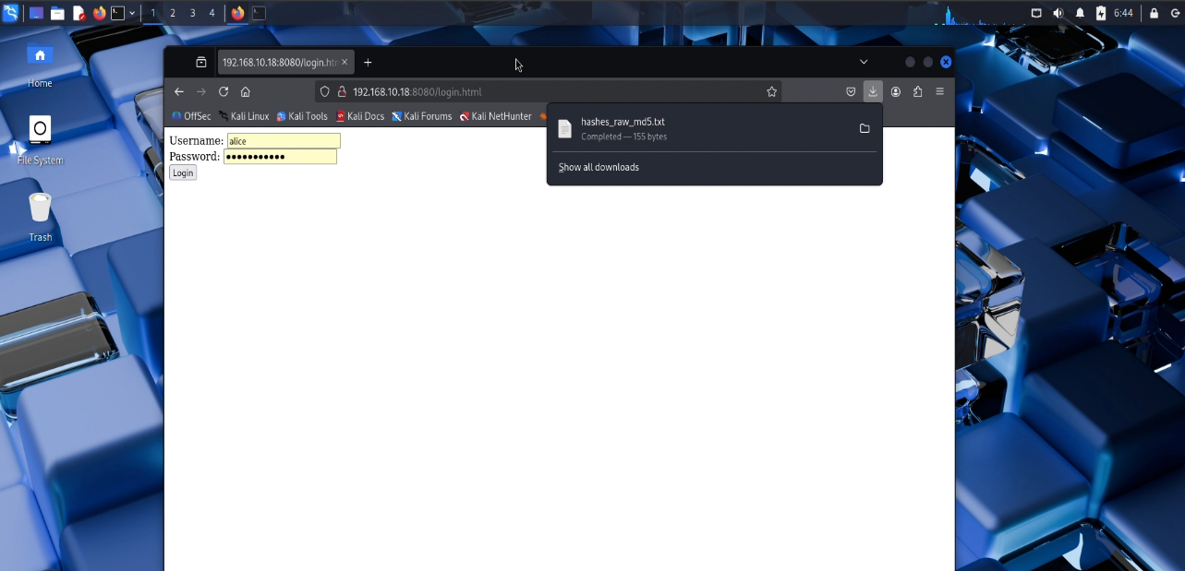
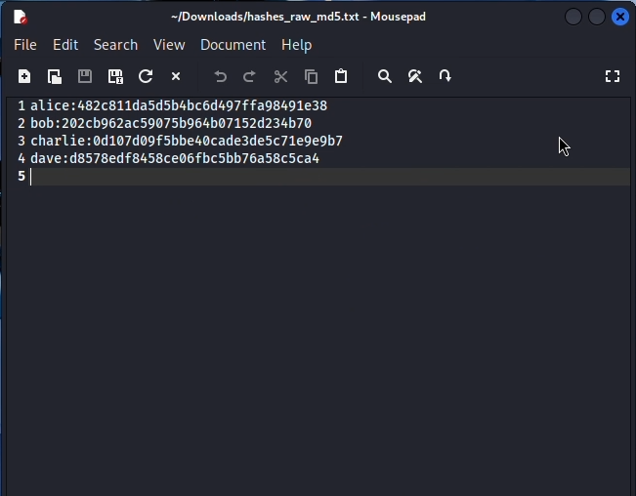

  - We will use John the Ripper to crack MD5 hashes from a captured hash file, demonstrating how weak passwords can be recovered using dictionary attacks. The John the Ripper command utilizes the --format=raw-md5 option to specify MD5 hash format, employs the --wordlist=/usr/share/wordlists/rockyou.txt parameter to conduct a dictionary attack using the rockyou wordlist, and targets the hashes_raw_md5.txt input file containing the MD5 password hashes to be cracked.
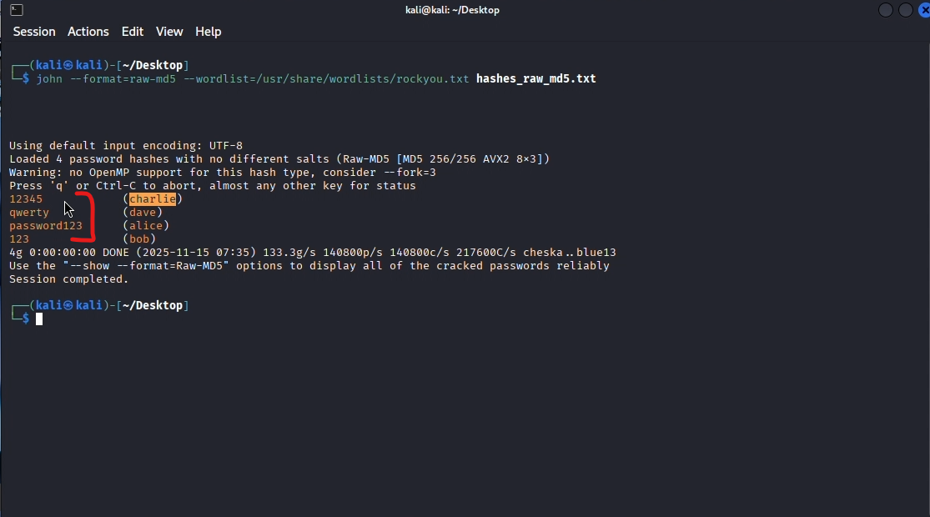
We manage to get the passwords form the hashes as we can see in the image above.

  - We can also use Hashcat as an alternative to John the Ripper for password hash cracking but first we should edit the file to contain only the hashes of the passwords.

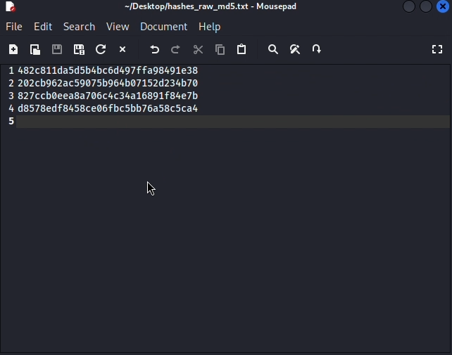 w
execute the Hashcat command hashcat -m 0 -a 0 hashes_raw_md5.txt /usr/share/wordlists/rockyou.txt. The Hashcat command is configured with -m 0 to specify MD5 hash type, uses -a 0 to perform a straight dictionary attack mode using the rockyou wordlist. After execution, display the successfully cracked passwords using hashcat -m 0 --show hashes_raw_md5.txt command.
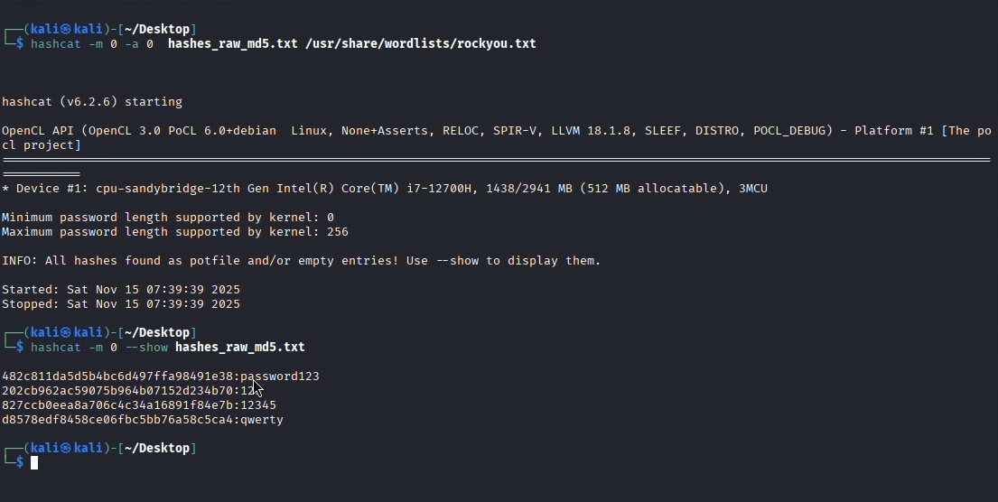

References
- Nmap. (2024). Nmap Security Scanner. Nmap.org. https://nmap.org/
- MITRE. (2023). ARP Spoofing (T1557.002) – MITRE ATT&CK®. https://attack.mitre.org/techniques/T1557/002/
- Kali Linux Documentation. (2024). Kali Linux Tools & Usage. https://www.kali.org/docs/
- Openwall. (2024). John the Ripper Password Cracker. https://www.openwall.com/john/
- Hashcat Project. (2023). Hashcat Advanced Password Recovery. https://hashcat.net/hashcat/
- Express.js. (2024). Express Web Framework Documentation. https://expressjs.com/
- Node.js Foundation. (2024). Introduction to Node.js. https://nodejs.org/en/learn
- Arch Linux Manual. (2024). arpspoof(8) — User Commands. https://man.archlinux.org/man/arpspoof.8
- Linux man pages. (2024). tcpdump(1) — Packet Capture Tool. https://man7.org/linux/man-pages/man1/tcpdump.1.html
- Wireshark. (2025). tshark(1) Manual Page. Wireshark.org. https://www.wireshark.org/docs/man-pages/tshark.html

